**HUMAN RESOURCE MANAGEMENT SYSTEM**

**INTRODUCTION TO SOFTWARE ENGINEERING**

**JANUARY 28, 2023**

**GROUP MEMBERS**

**HADIQA MEHDI 21B-007-SE (SE- B)**

**MAIRA USMAN 21B-011-SE (SE- B)**

**MUSFIRA KHALID 21B-027-SE (SE- B)**

**COURSE INSTRUCTOR**

**SIR USMAN WAHEED**

**PROJECT ANALYST:AMNA SHADAT**

**USMAN INSTITUTE OF TECHNOLOGY**

**Table of Contents**

**ABSTRACT** **2**

**List of Figures 3**

**ACKNOWLEDGMENT** **4**

**HR MANAGEMENT SYSTEM** **4**

1. INTRODUCTION AND OVERVIEW 4

2. MODULES 5-6

3. BACKGROUND 6

4. AIM AND STATEMENT OF PROBLEM 7

5. METHODS ,ASSUMPTIONS AND PROCEDURES 7

6. AVAILABLE RELEVANT SOLUTION 9

7. ANALYSIS AND DESIGN 9

**4**

# ABSTRACT

To maintain the data of all active and inactive employees requires a significant amount of time if we do it without software. Every organization has their own human resources in order to perform the internal and external human resource activities. Among the total human resource activities, managing the human capital i.e., employees is the significant task to any HR. The main function of HR is to recruit, manage and store the employee data which includes their personal information including their job roles, job streams, projects allotted, salaries and many more which allows them to face huge workload. In order to support the HR’s, there are some electronic based HR systems called HR. Human resource management system. Organisations should maintain HRMS software with a huge number of client server applications, service providers as well as control tools. But this application is a cost effective one that allows them to manage their employee’s data in a simple manner. This human resource management system will allow the HRs to manage the timings of employee works, employee information systems, employees recruitment, employees training, employee retention and performance appraisal, employee service and employee attendance. This project belongs to a category of web application that can be accessed through PC with internet connection.

# 

# List of Figures

|  |  |  |
| --- | --- | --- |
| Figure No. | Description | Page No. |
| 1.1 | Swimlane diagram | 11 |
| 1.2 | Context diagram | 12 |
| 1.3 | Actor use case | 13 |
| 1.4 | Object diagram | 14-17 |
| 1.5 | Sequence diagram | 18 |
| 1.6 | Component diagram | 19 |

# ACKNOWLEDGMENT

First of all Alhamdulillah. Our project is able to be completed within a given time frame.

Secondly, we would like to express our deepest gratitude to our teacher Sir Usman Waheed for his extraordinary efforts in providing guidance throughout the project and helping us to complete the project.

We really appreciate your cooperation and time spent during this semester, thanks for the full support that you gave us.

We also sincerely appreciate Abbas Rizvi for taking out time to help us. Their expertise and commitment allowed us to complete this project smoothly.

# HR MANAGEMENT SYSTEM

## INTRODUCTION AND OVERVIEW

A human resources management system or Human Resources Information System or Human Capital Management is a form of Human Resources software that combines a number of systems and processes to ensure the easy management of human resources, business processes and data Human resources software is used by businesses /companies to combine a number of necessary HR functions, such as storing employee data, managing payroll, recruitment, benefits administration (total rewards ), time, employee performance management, and assigning tasks. And employee to complete tasks, apply for leave ,update information receive paycheck, Finance department to generate payslip, Admin(owner) to give approval .All the data fed in the **HRMS** is uploaded on systems interfaces .This interface can easily be accessed by the employees and the admin, with the help of proper security credentials. This gives adequate and secure accessibility which in turn leads to transparency between the admin and the employee. It also reduces the chances of miscommunication and leads to improved coordination and comprehension amongst the team.

## MODULES

## Our system has three main interfaces which are:-HR, EMPLOYEE ,FINANCE, Along with these we have other interfaces as mentioned below:

* 1. **Login:**

The Login Module is a portal module that allows users to type a username and password to log in. You can add this module on any module tab to allow users to log in to the system. If system receives an unregistered or unrecognised email and pass it will give error message.

* 1. **Fill application form:**

When filling out a form, your goal is to provide complete, correct information. To enter into the organisation the candidate is required to fill the form by filling their name, gender, selecting designation in drag drop box, any a lot more details

* 1. **HR:**

HR provides a single source of information about employees and applicants. Assign task, monitor performance, shortlist candidate. It can overview, edit, and update employee information.

* 1. **Employee:**

Login into the system and receives payslip, complete task, edit and update info.

* 1. **Finance:**

Login into the system in their profile, edit and update employee information, generates payslip can upload a photo and logout.

* 1. **Candidate information:**

HR enters employee contact no, gender, address, qualification and shortlist them.

* 1. **Employee information:** HR enters ID, name, department, position, email, address and phone number of the employee and picture can also be added and this information can later be changed and updated if needed.
  2. **Assign task:**

HR enter the task, employee name and task number, starting and ending date into the system.

* 1. **Employee performance:**

Employee performance is monitored by the HR and in this interface HR enters name, date and rating of the employee based on the completion of task and save the data.

* 1. **Add employee:**

HR enters ID, name, department, position, email, address and phone number of the employee and picture can also be added.

* 1. **Delete employee:**

Box in which u can enter the employee’s name and delete the existing data from the system.

* 1. **Update employee information:**

Makes changes in the already given information to the system.

* 1. **Generate payslip.**

A box of question is asked before generating the payslip then based on performance, bonus, deduction and conveyance net salary is calculated by finance department and received by employee on the system.

* 1. **Logout:**

 when you finish, you will log out so that no one else can access your files without permission.

## 

## BACKGROUND

The trend of [automating payroll](https://en.wikipedia.org/wiki/Payroll_automation) and workforce management processes began during the 1970s. Due to limited technology and [mainframe computers](https://en.wikipedia.org/wiki/Mainframe_computer), companies were still relying on manual entry to conduct employee evaluation and to digitise reporting and help bridge the gap between employees' performance and the organisation's strategic objectives. Moreover, an efficient HR management team can give firms an edge over their competition. Recruitment: One of the major responsibilities of a HR manager is to recruit personnel.

## AIM AND STATEMENT OF PROBLEM

## Human resource planning (HRP) allows a business to better maintain and target the right kind of talent to employ — having the right technical and soft skills to optimise their function within the company. It also allows managers to better train and develop the skills needed amongst the workforce. Human resource planning allows companies to plan ahead so they can maintain a steady supply of skilled employees. That's why it is also referred to as workforce planning. The process is used to help companies evaluate their needs and to plan ahead to meet those needs.

## METHODS ,ASSUMPTIONS AND PROCEDURES

## These are just some of the flows of previous HR software.

## 

## 

## **1. A disorganised HR system:**

## This is what happens when businesses don’t utilise their people processes and data effectively: the epitome of disorganisation. And it’s all-too-common for SMBs who are using a manual or outdated Human Resources Information System (HRIS).

## 

## **2.Lack of employee Management:**

## An outdated HR system – or no HR software at all – can lead you to unintentionally neglect your employees, as you’re unlikely to have reminders in place to carry out performance reviews. This can result in a high employee turnover and a lack of progression.

**3. Miscommunication issues**

HR is responsible for a lot of communication within a business: training, wages, benefits, general company news...

But often, the bridge connecting employees with leadership is broken and messages don’t get passed down sufficiently. Miscommunication is one of the key disadvantages of old HR software.

If you’ve experienced issues involving sick days, holidays, or employees clocking in and out at the wrong time, you’ll know the impact a breakdown in communication can have to an SMB. At worst, it can cause you to fall behind on crucial projects.

**4.NO DATA OF SALARY:**

There was no data of salary received by the employees in the previous system

**5.NO TRACK OF PERFORMANCE:**

The performance of clients existing was not good and was not giving required throughput.

## AVAILABLE RELEVANT SOLUTION

We have gone through many websites in order to collect ideas for our project and visited the company to gather detailed information about their management system. It included different departments to assign, monitor , approve and complete task. They were provided with a database; each department has its own database to enter and check data. All of the examples helped us a lot in analysing the problems and designing the solution.

7.ANALYSIS AND DESIGN:

For making this project ,we have to use techniques like business process workflow/swim lane , context diagram, object diagram and actor use diagram.

* Recruitment and Selection
* Development
* Performance Management
* Employee Compensation and Benefits
* Calculate Payroll .

# SWIMLANE DIAGRAM:

# A swim lane (as in swim lane diagram) is used in process flow diagrams, or flowcharts, that visually distinguishes job sharing and responsibilities for sub-processes of a business process. Swim lane may be arranged either horizontally or vertically.swimalne diagram of human resource management system(Fig 1.1) Swimlane of human resource management system

# 

# 

# 

# 

CONTEXT DIAGRAM:

A context diagram is a [diagram](https://en.wikipedia.org/wiki/Diagram) that defines the boundary between the [system](https://en.wikipedia.org/wiki/System), or part of a system, and its environment, showing the entities that interact with it. It is similar to a [block diagram](https://en.wikipedia.org/wiki/Block_diagram).

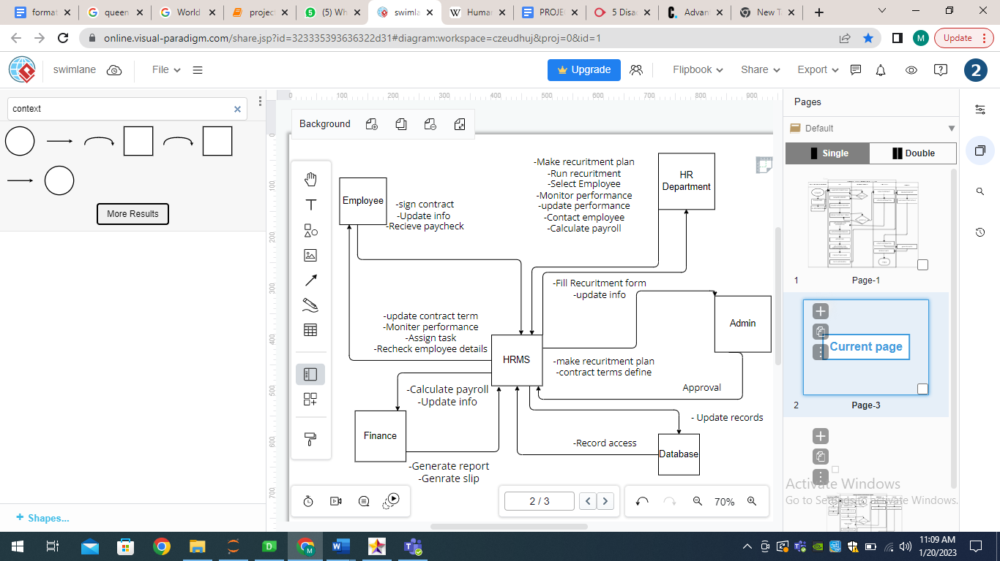(Fig 1.2) Context diagram of human resource management system

**ACTOR USE CASE DIAGRAM:**

A use case diagram shows the interaction between the system and entities external to the system. These external entities are referred to as actors. Actors represent roles which may include human users, external hardware or other systems

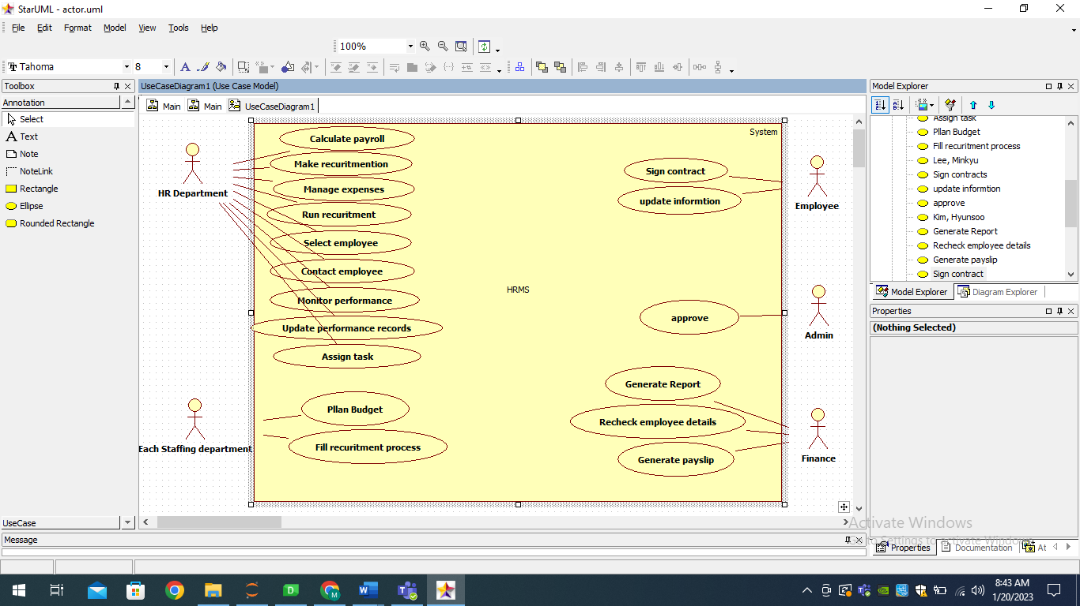(Fig 1.3) Actor use case diagram of human resource management system

**OBJECT DIAGRAM:**

An object diagram is a graph of instances, including objects and data values.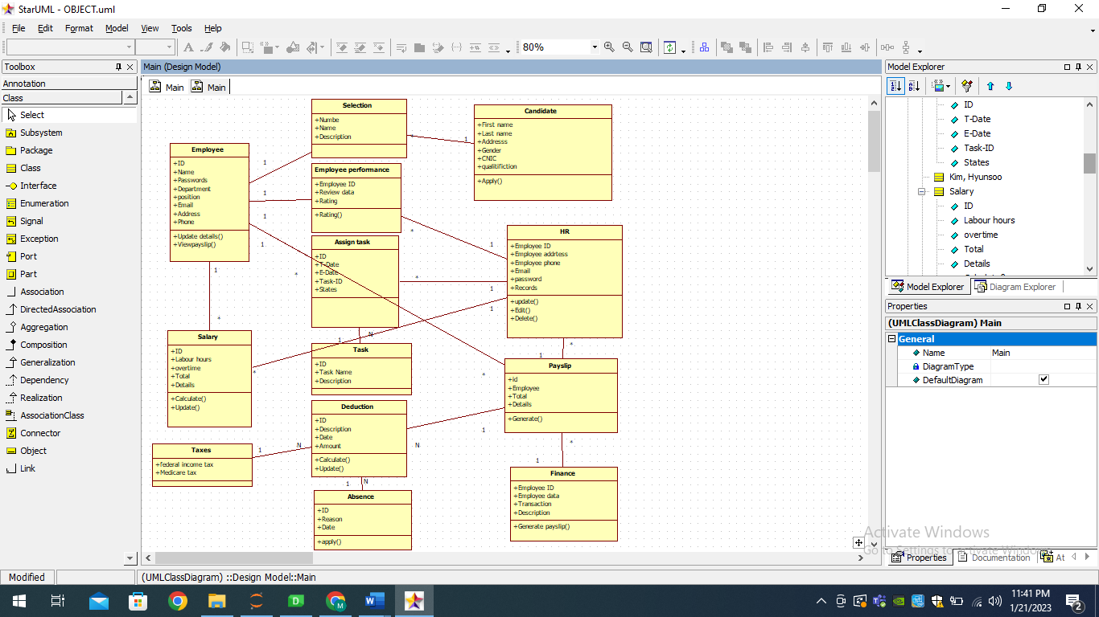

(Fig 1.4) Context diagram of human resource management system

Generate payslip diagram:

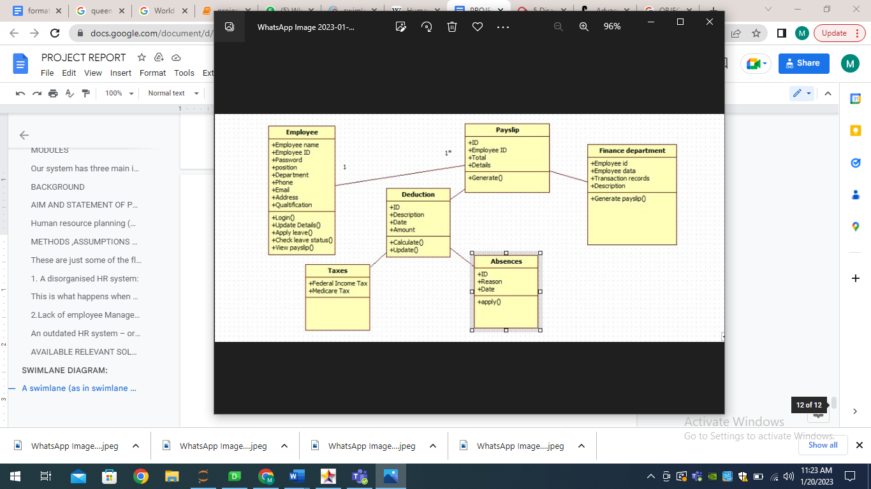

Calculate salary diagram:

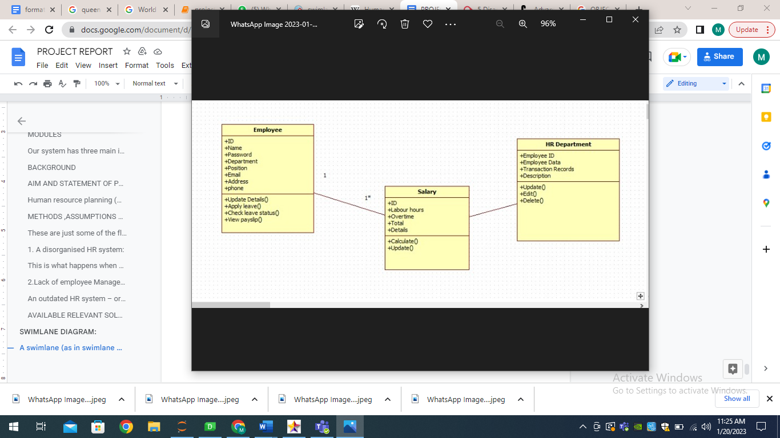

Run recruitment diagram:

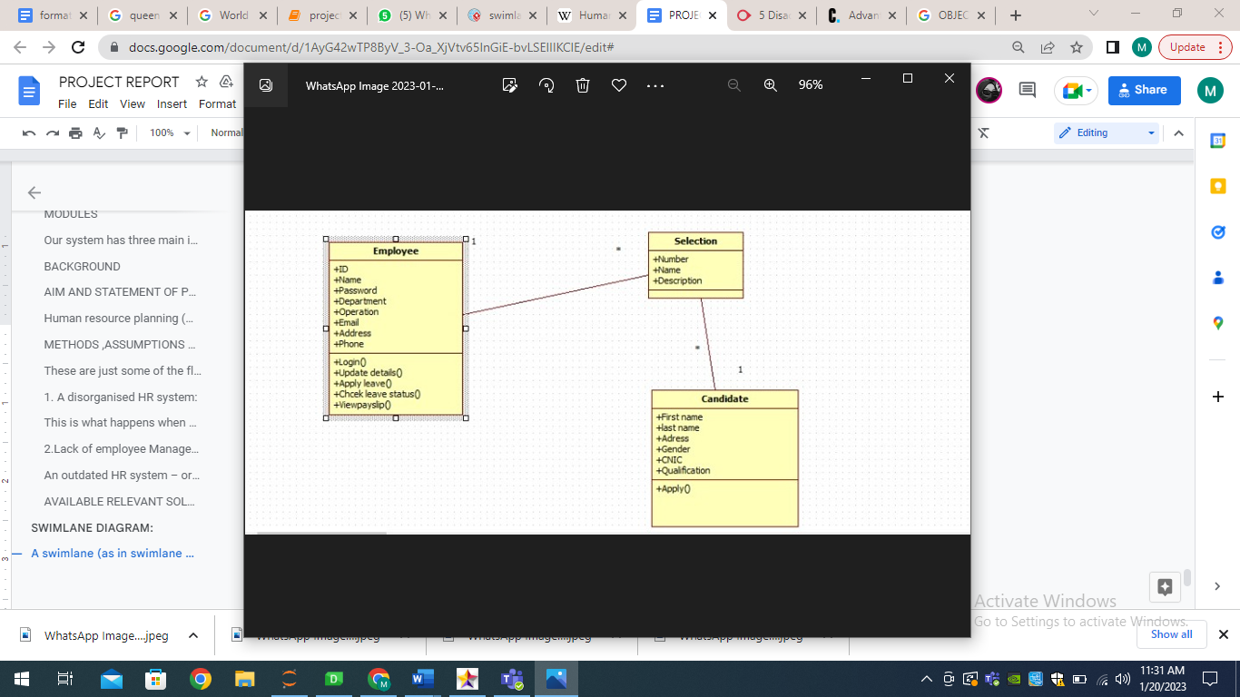

Update performance records:

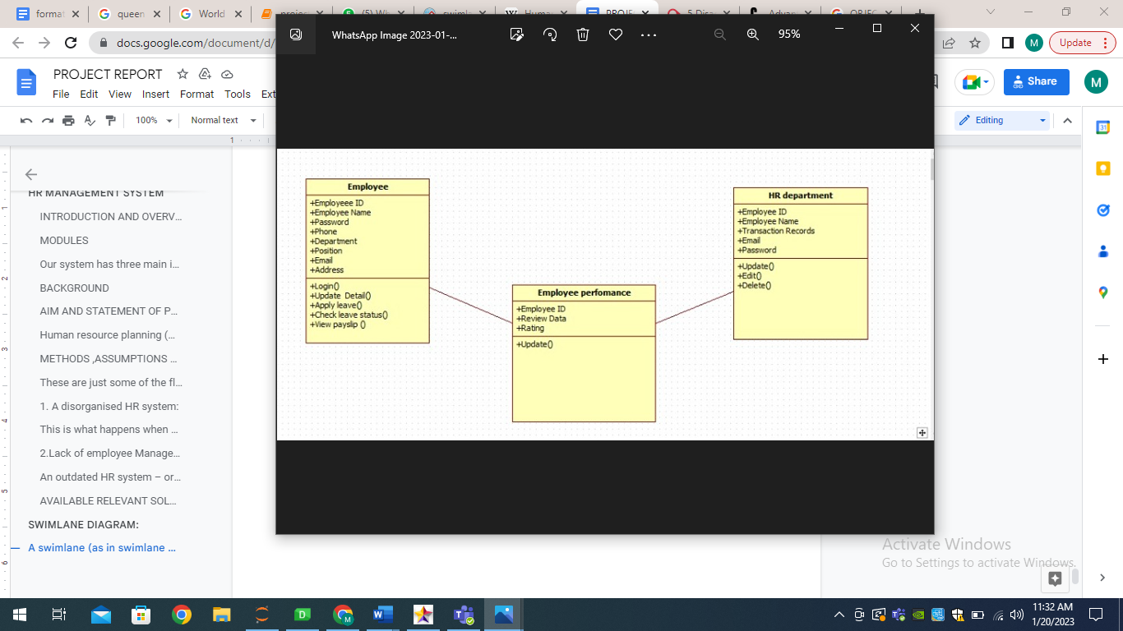

Assign Task Diagram:

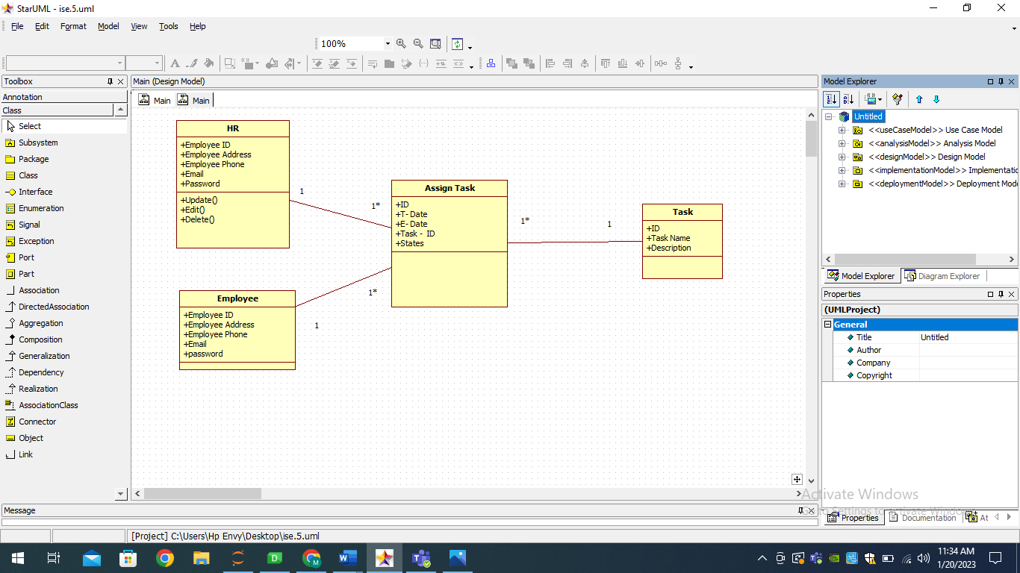

SEQUENCE DIAGRAM:

A sequence diagram is a Unified Modeling Language (UML) diagram that illustrates the sequence of messages between objects in an interaction. A sequence diagram consists of a group of objects that are represented by lifelines, and the messages that they exchange over time during the interaction.

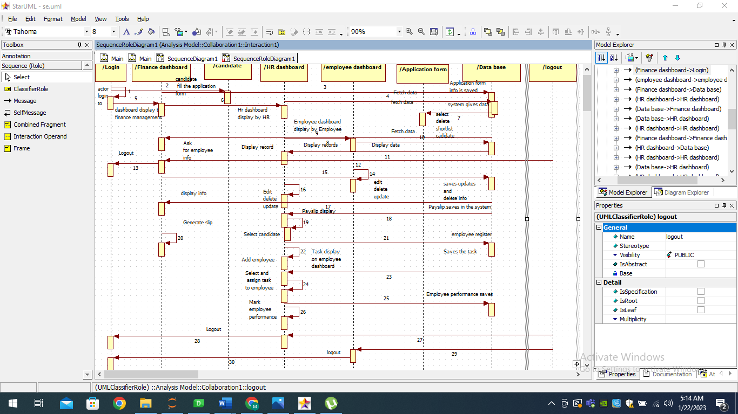

(Fig 1.5) Sequence diagram of human resource management system

COMPONENT DIAGRAM:

A component diagram, also known as a UML component diagram, describes the organization and wiring of the physical components in a system.

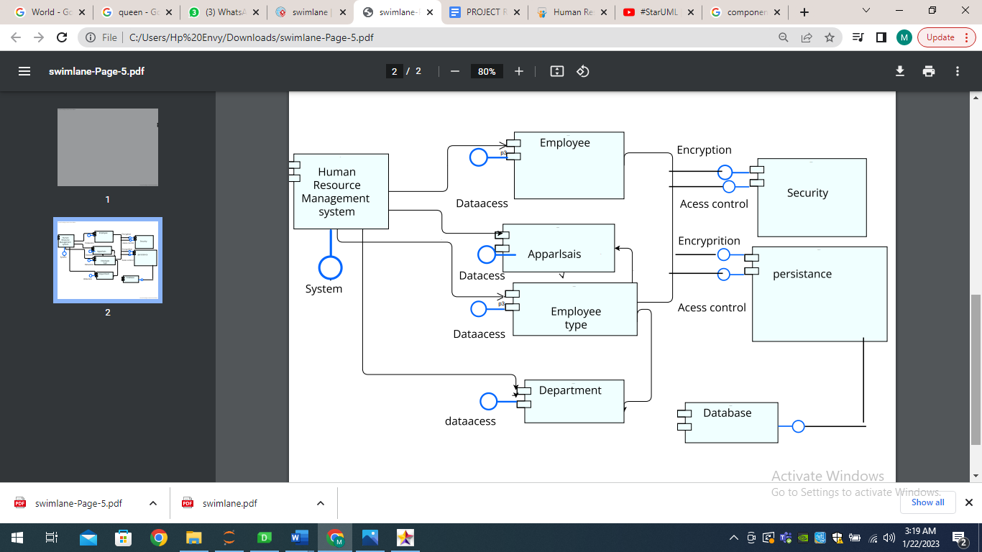

(Fig 1.6) Component diagram of human resource management system

ANALYSIS USE CASE DOCUMENTATION:

**1.contact employee:**

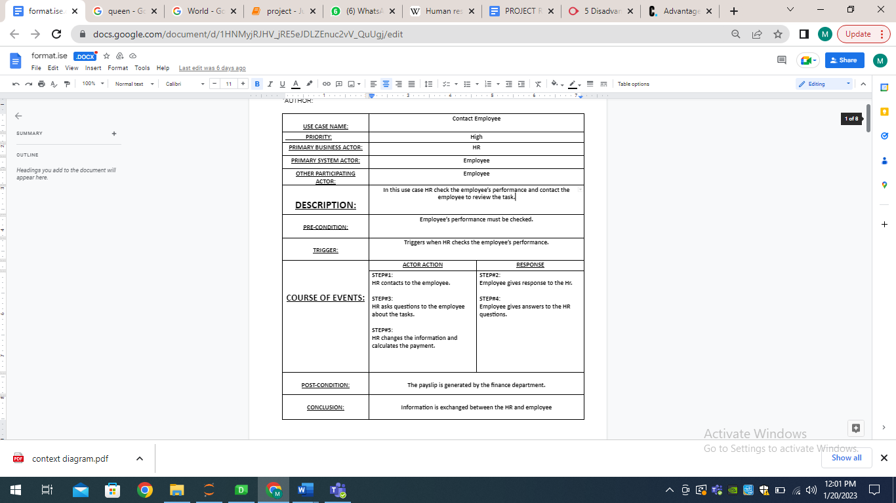

**2.update performance record**

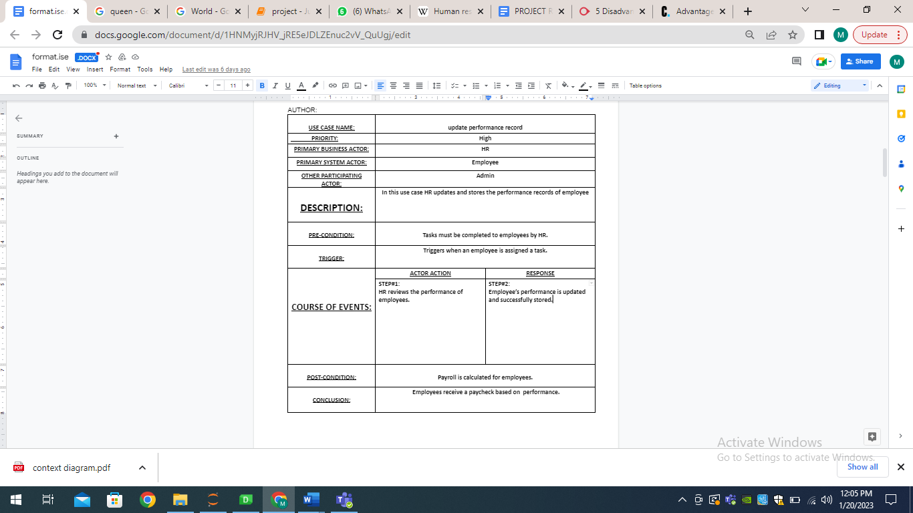

**3.calculate payment:**

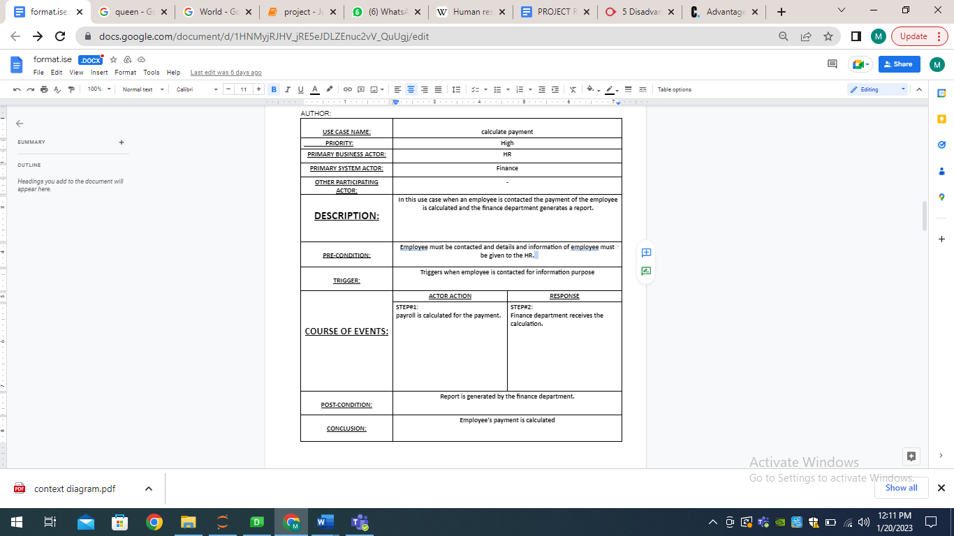

**4.Generatepayslip:**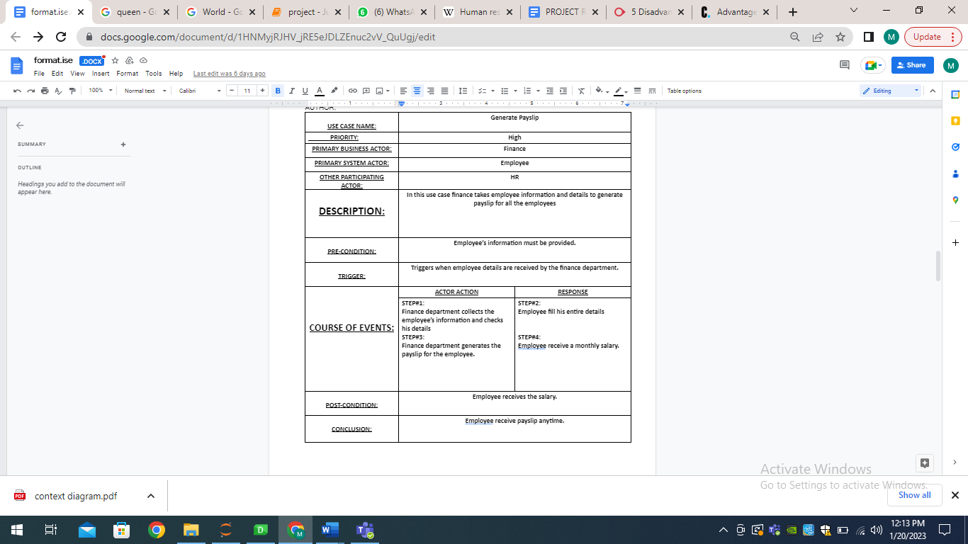

**5.Sign contract**

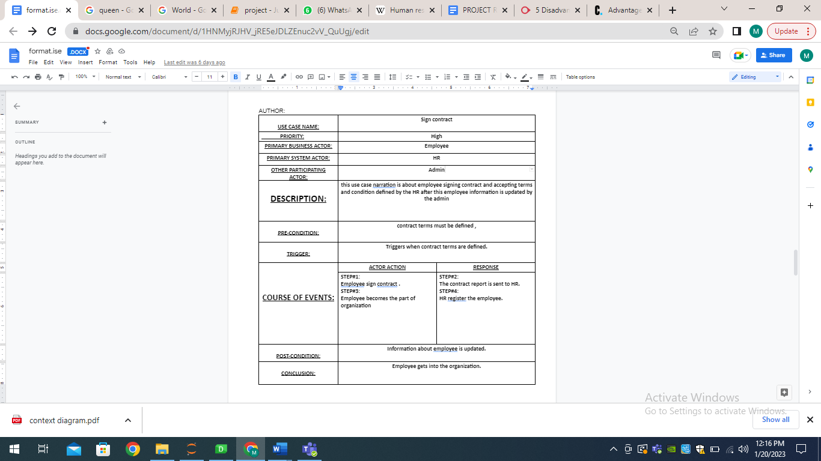

**6.Run recruitment:**

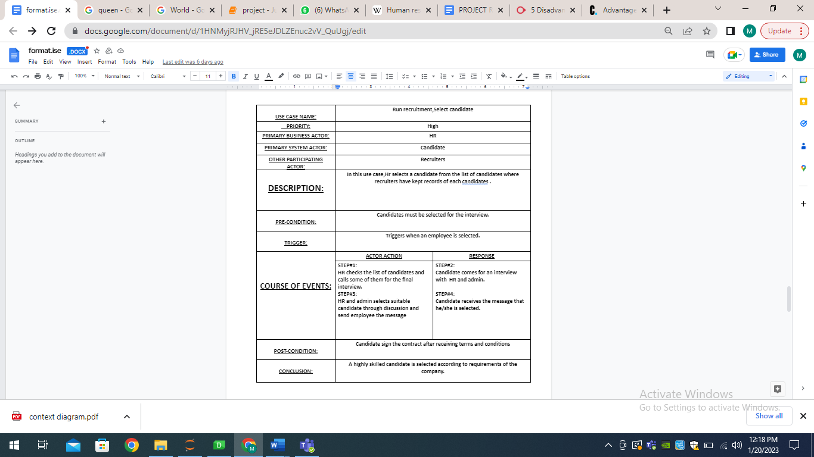

**7.Update information:**

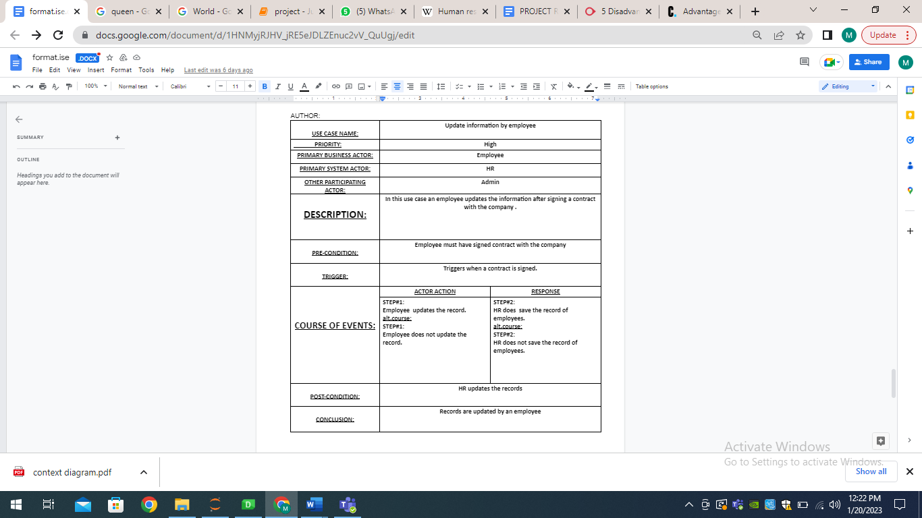

**8.AssignTask:  
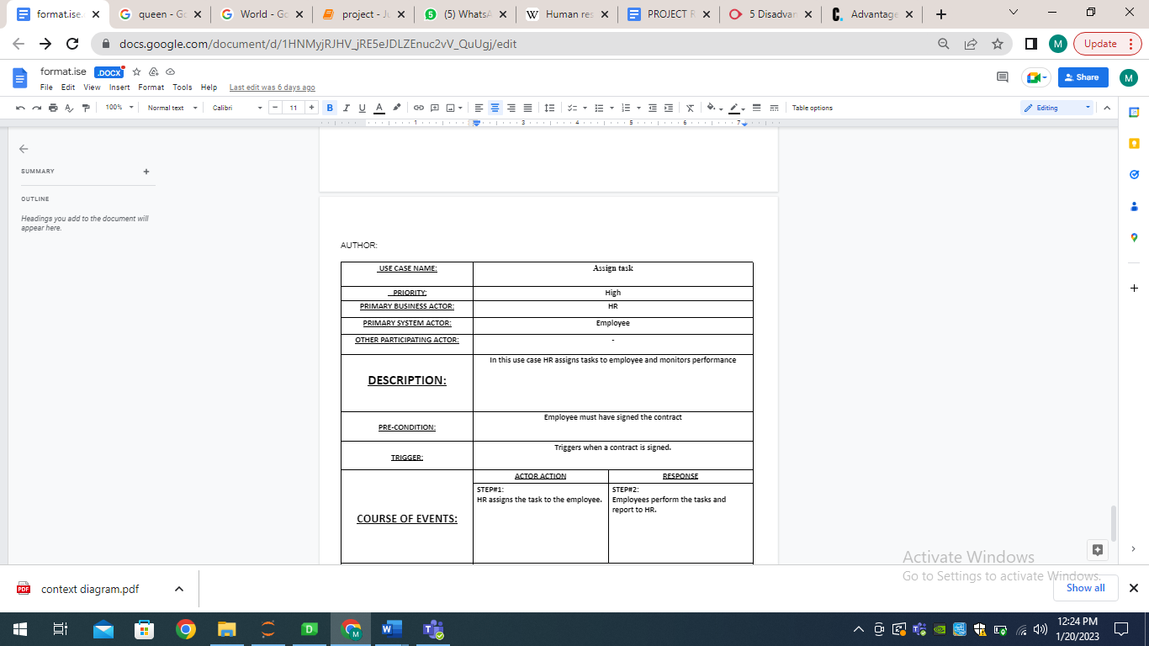**

DESIGN USE CASE DOCUMENTATION:

**1.contact employee:**

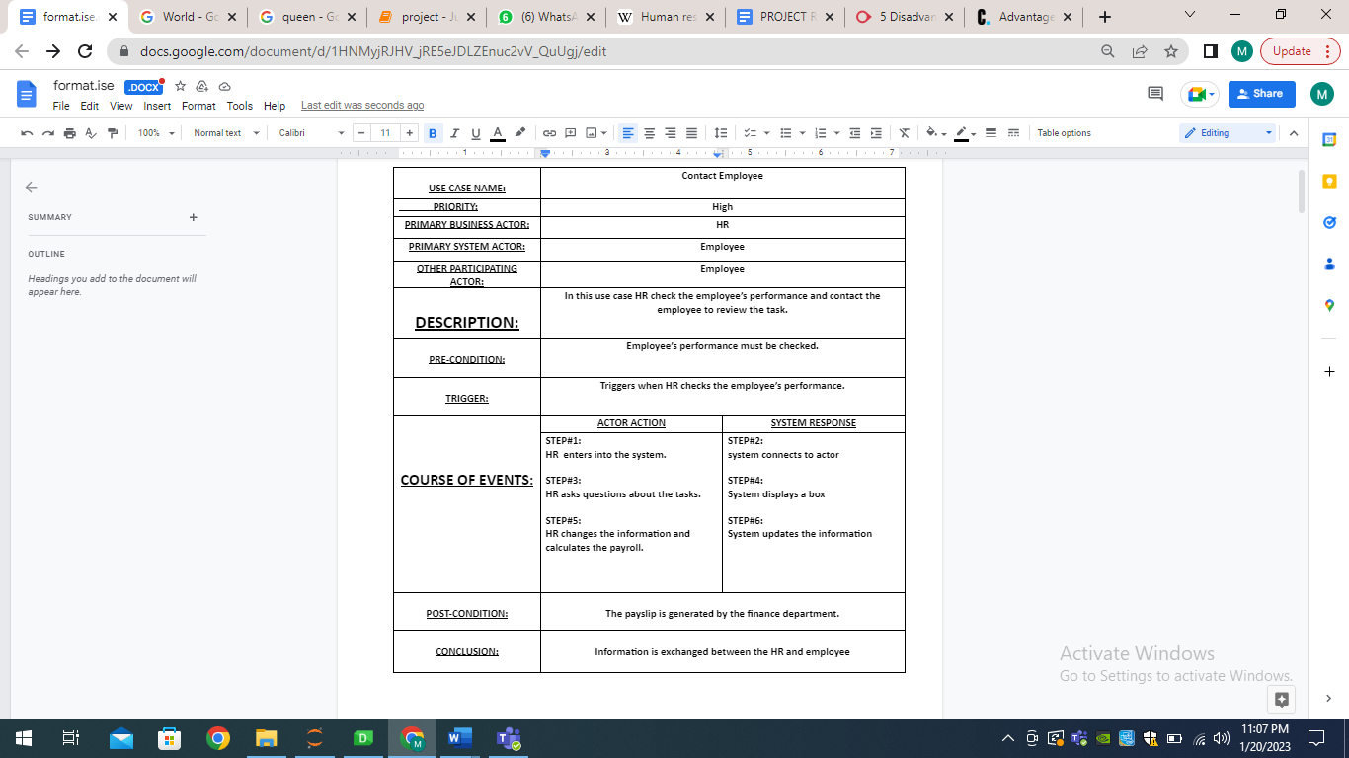

**2.Update performance record:**

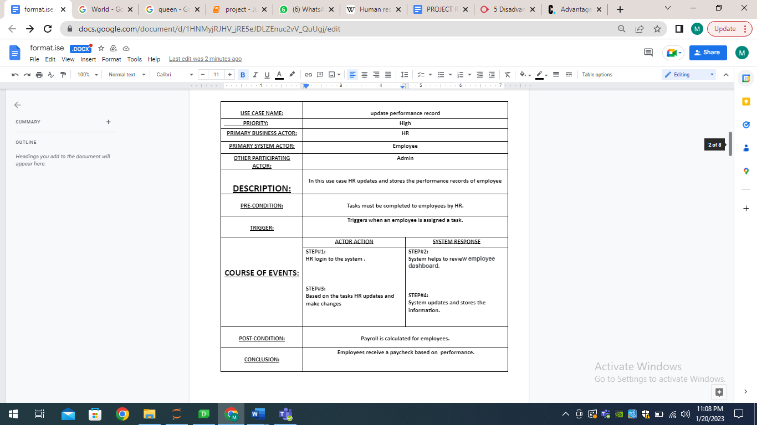

3.calculate payment

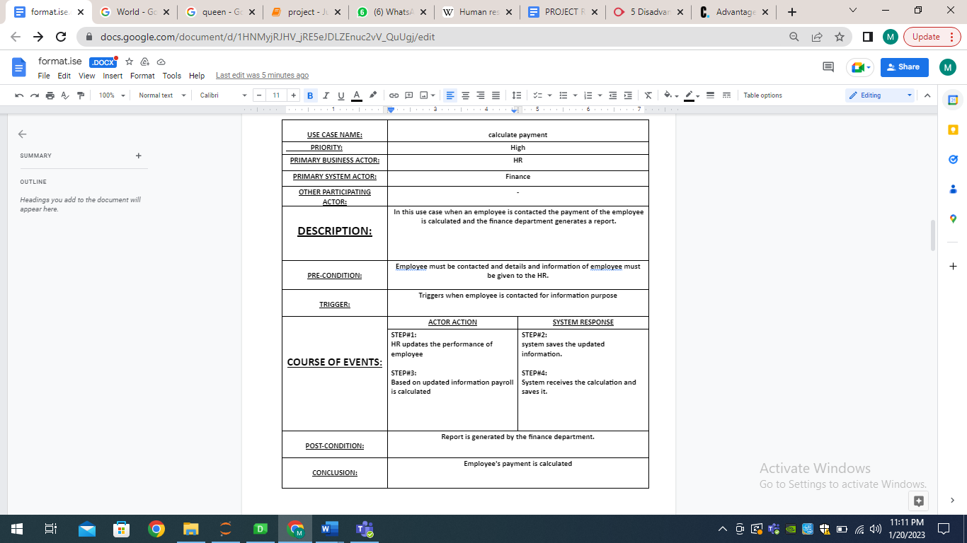

**4.Generatepayslip:**

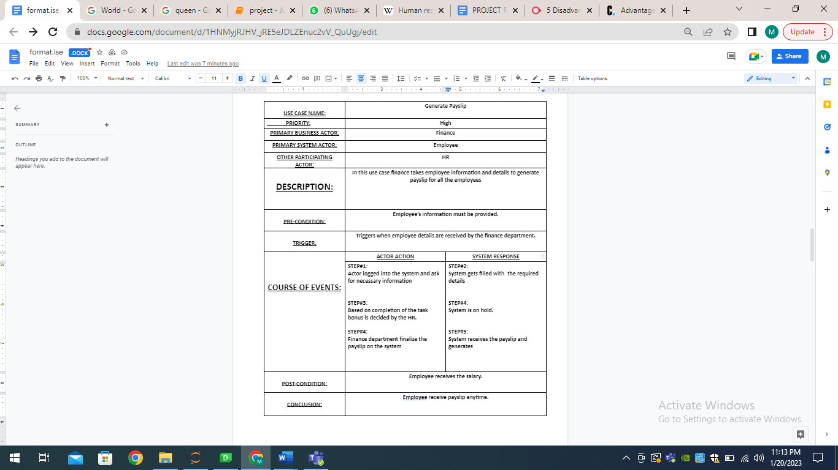

**5.sign contract:**

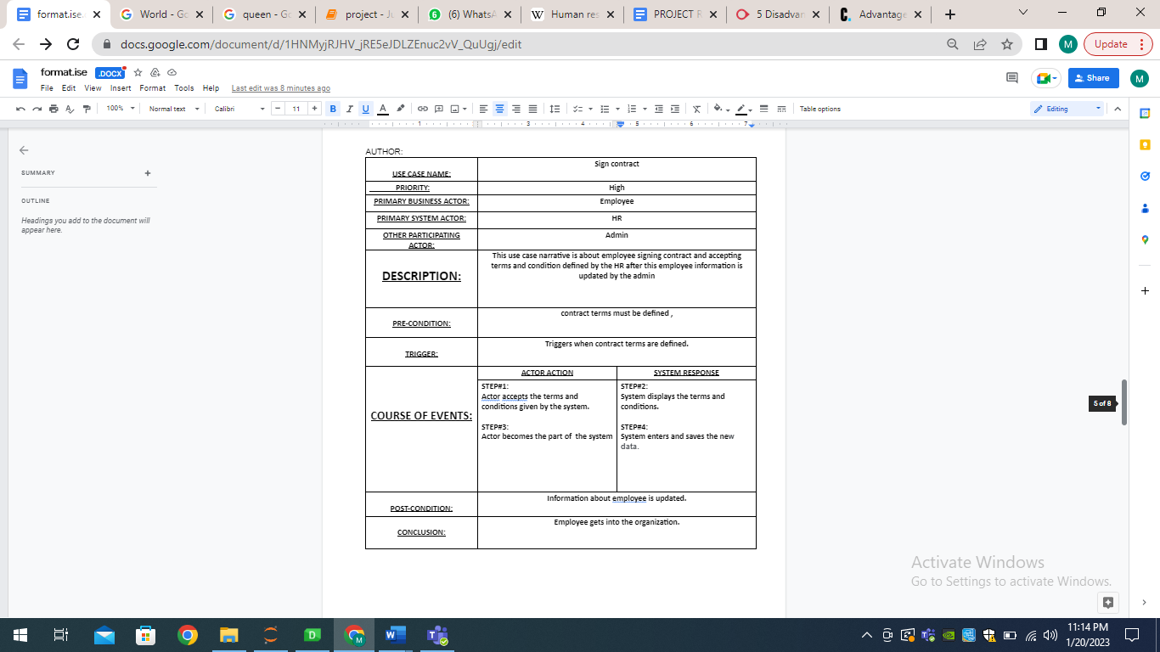

**6.Run recruitment:**

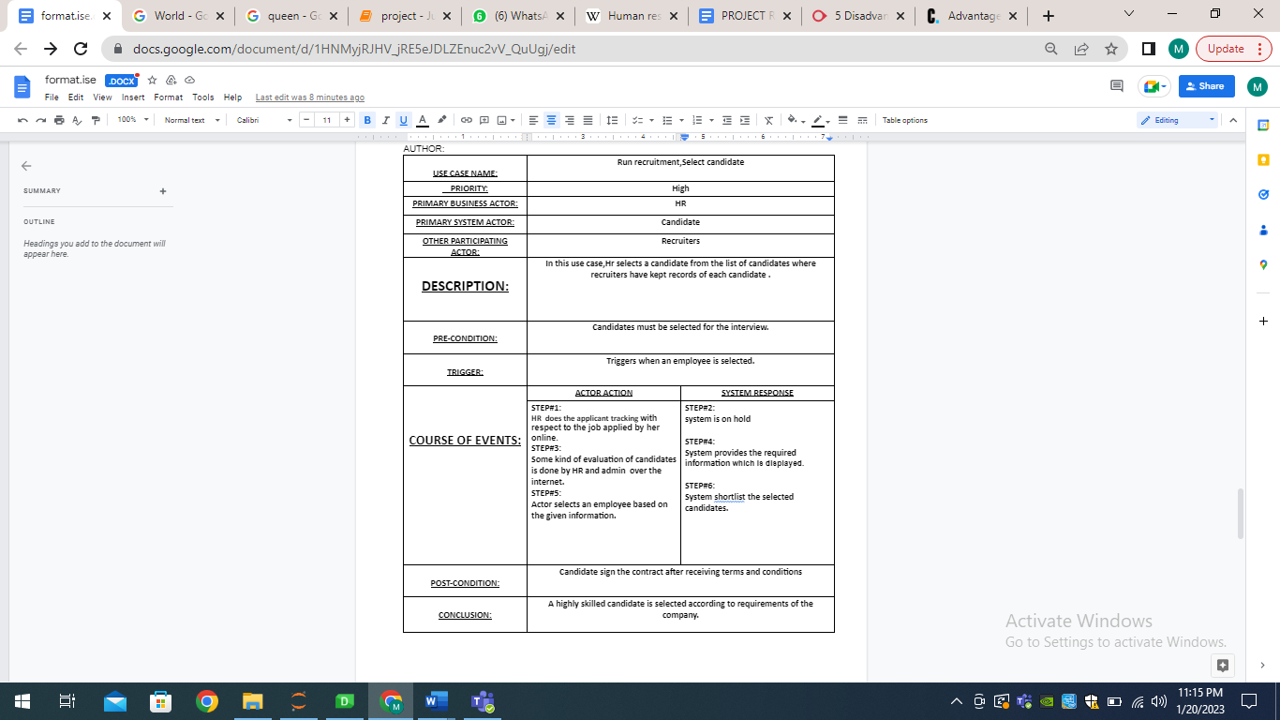

**7.Update information:**

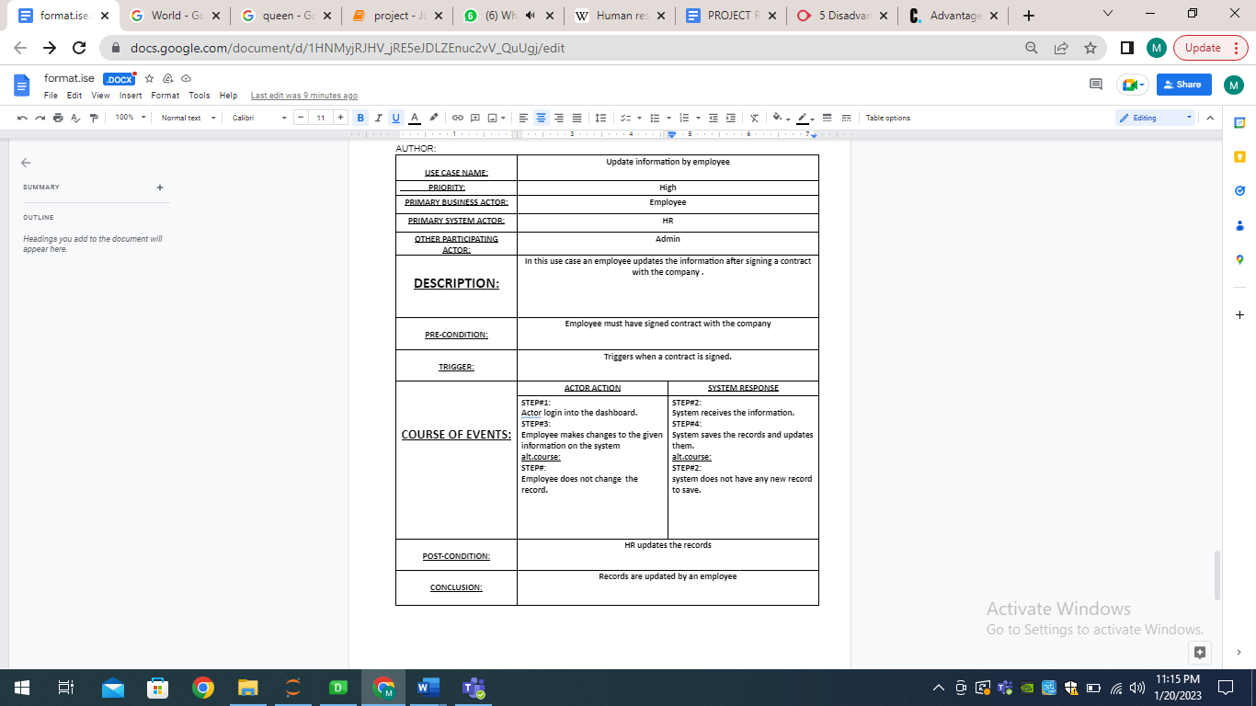

8.Assign task:

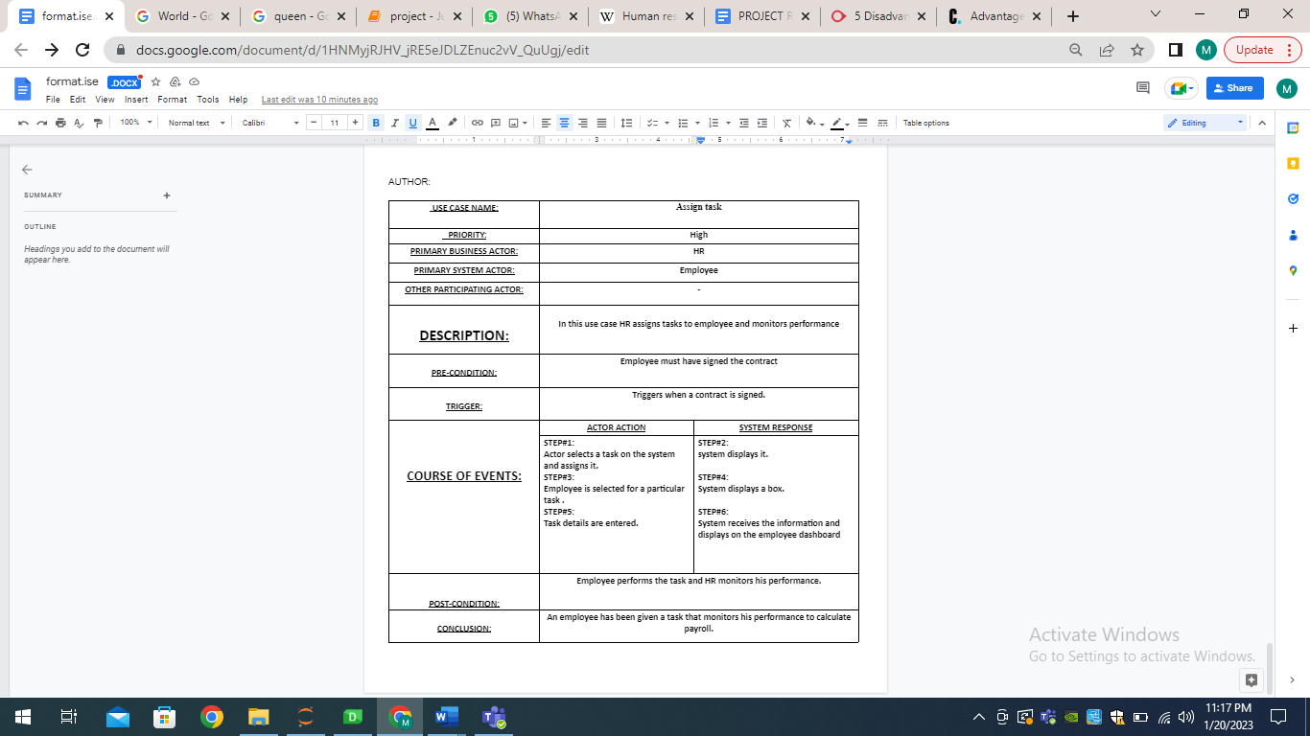

**IMPLEMENTATION:**

**Login:**

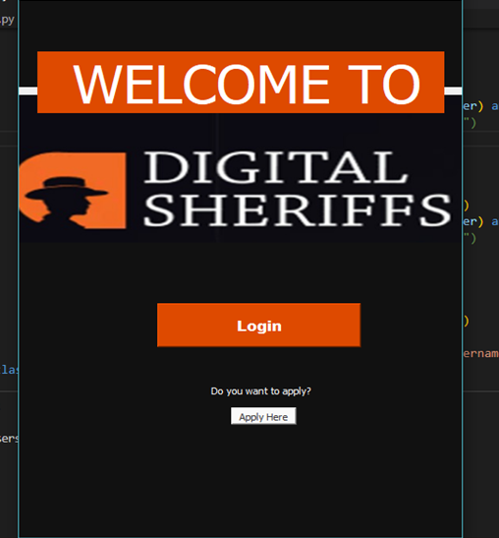

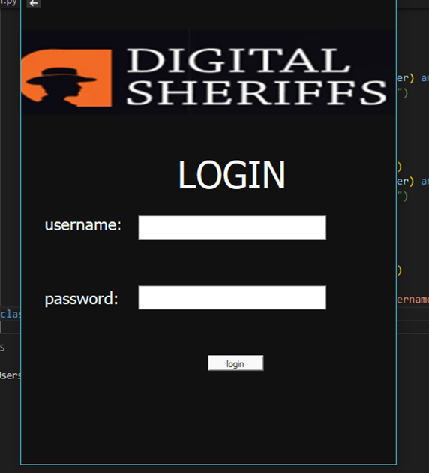

**APPLICATION FORM:**

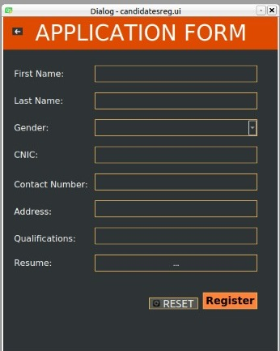

**HR Dashboard:**

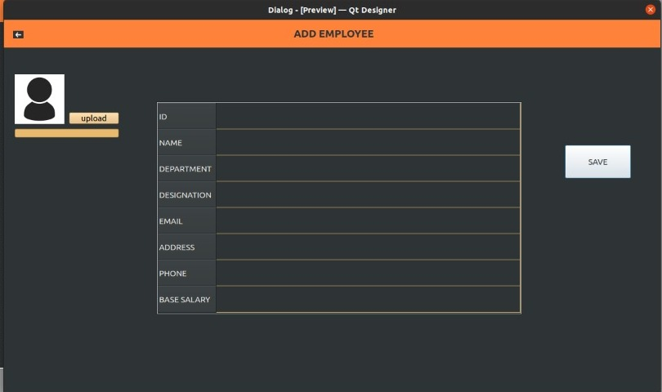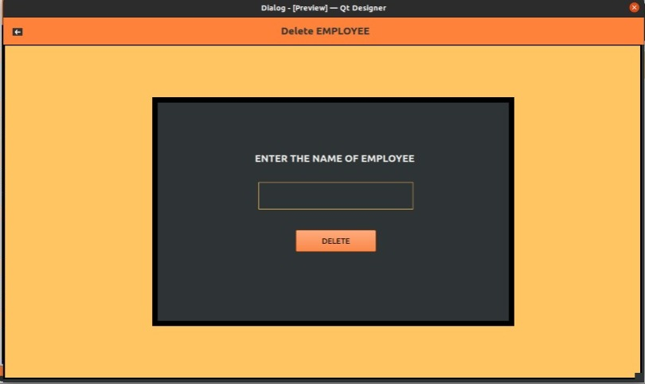

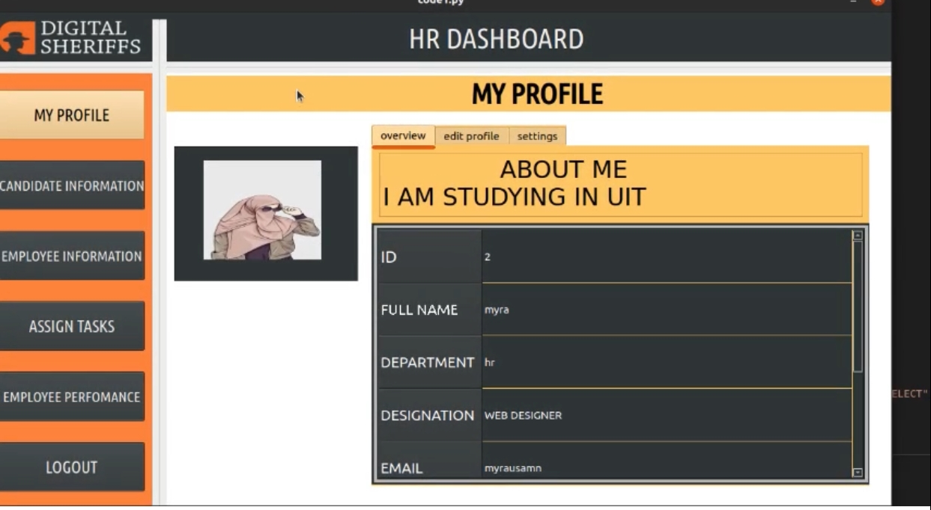

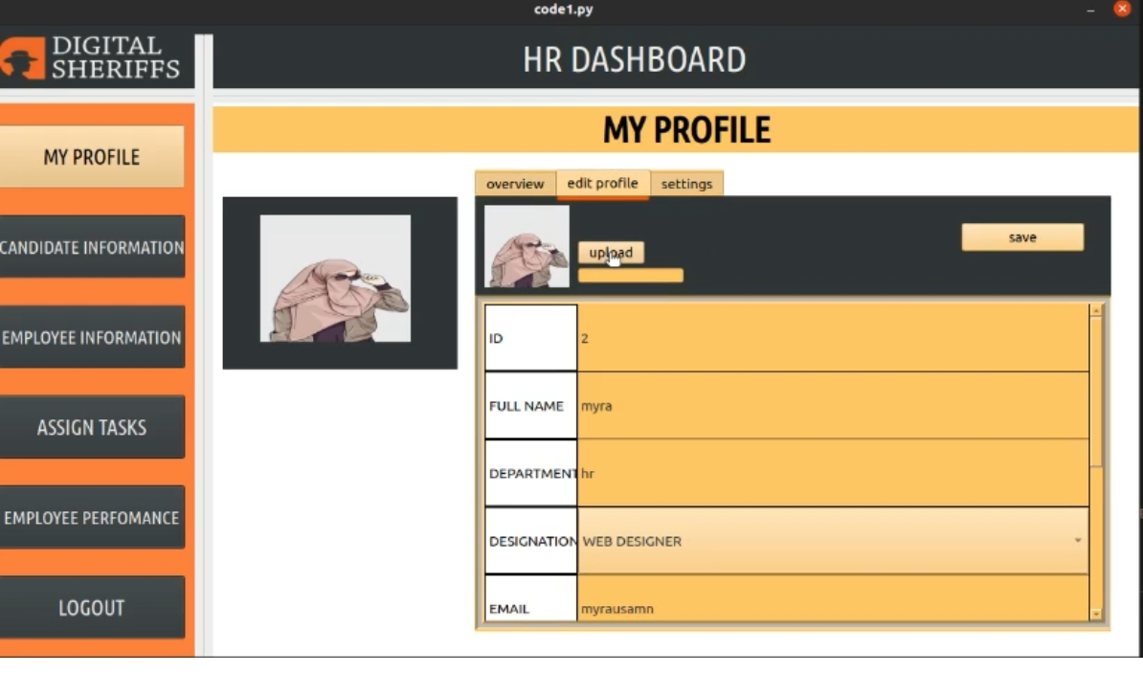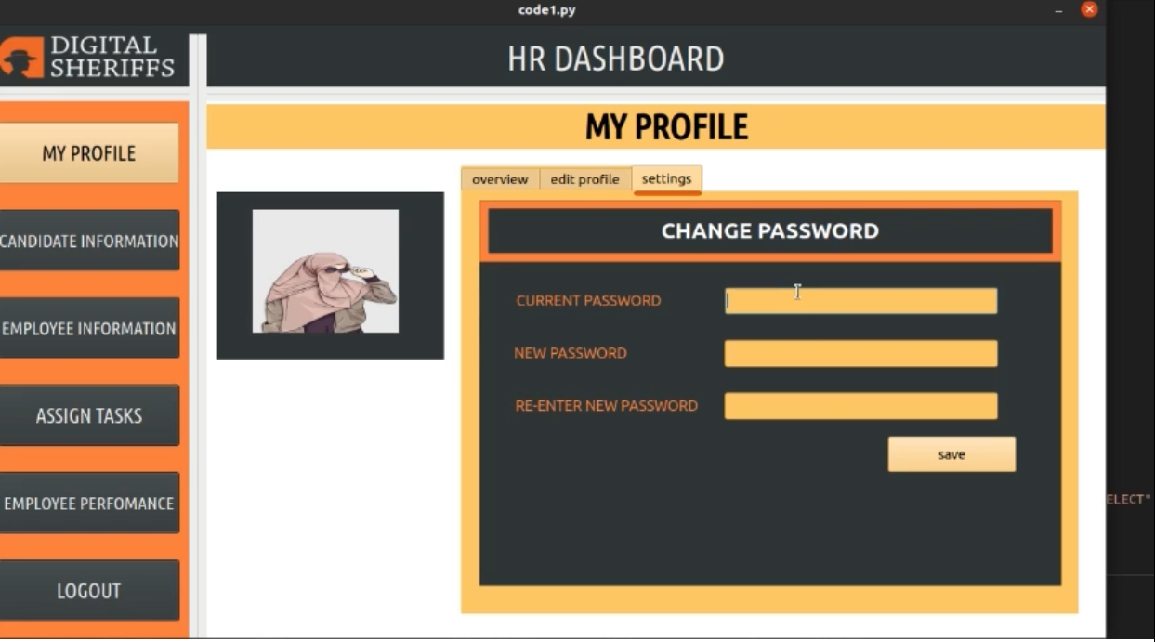

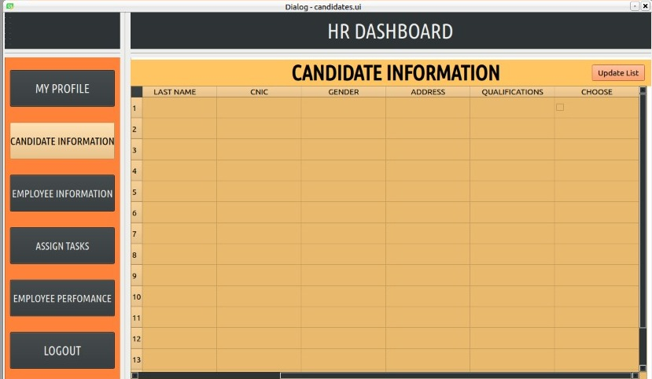

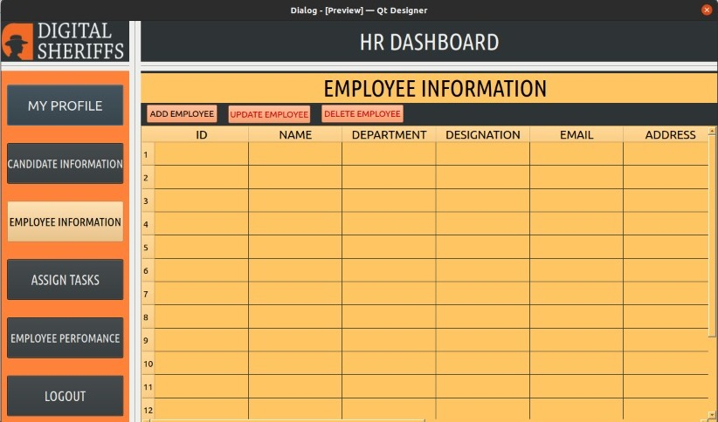

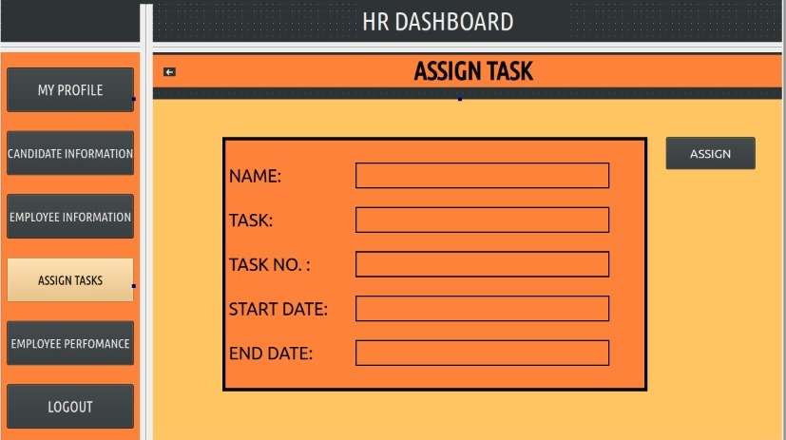

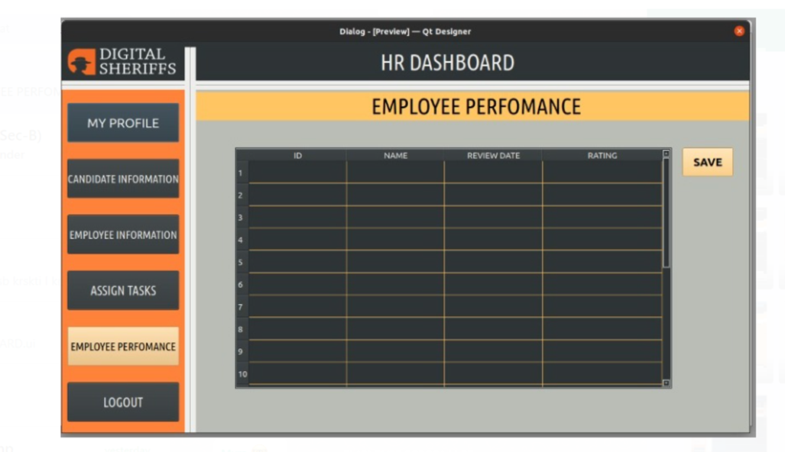

**Employee dashboard:**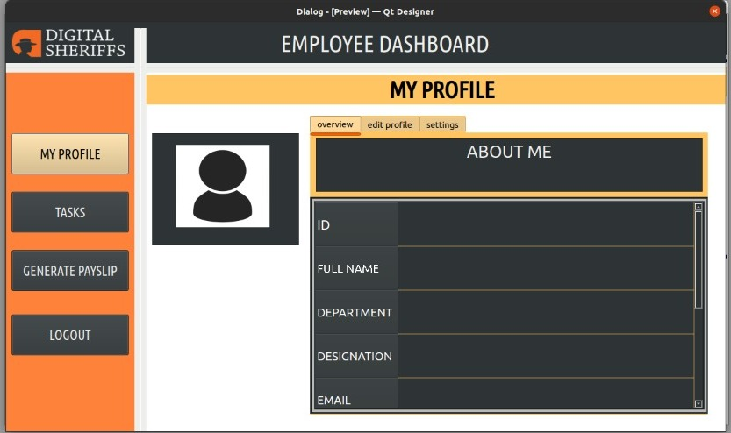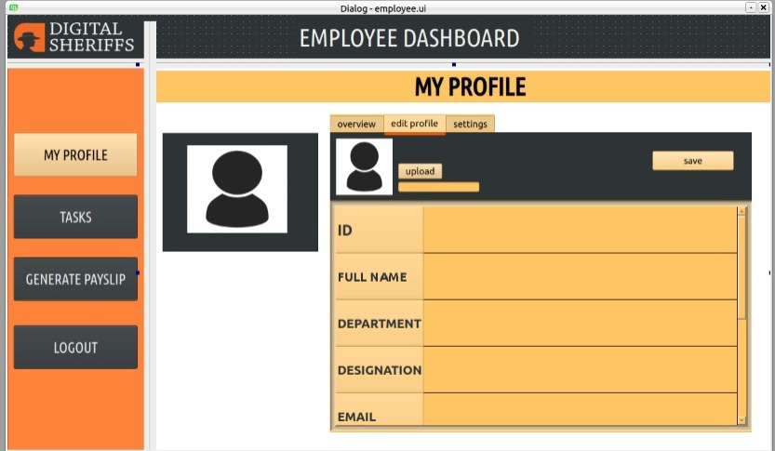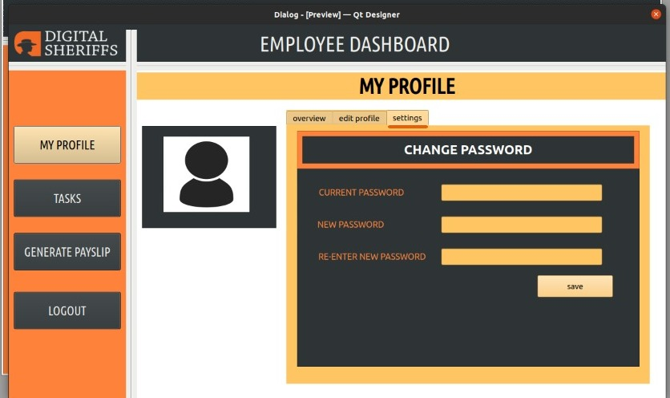

**FINANCE:**

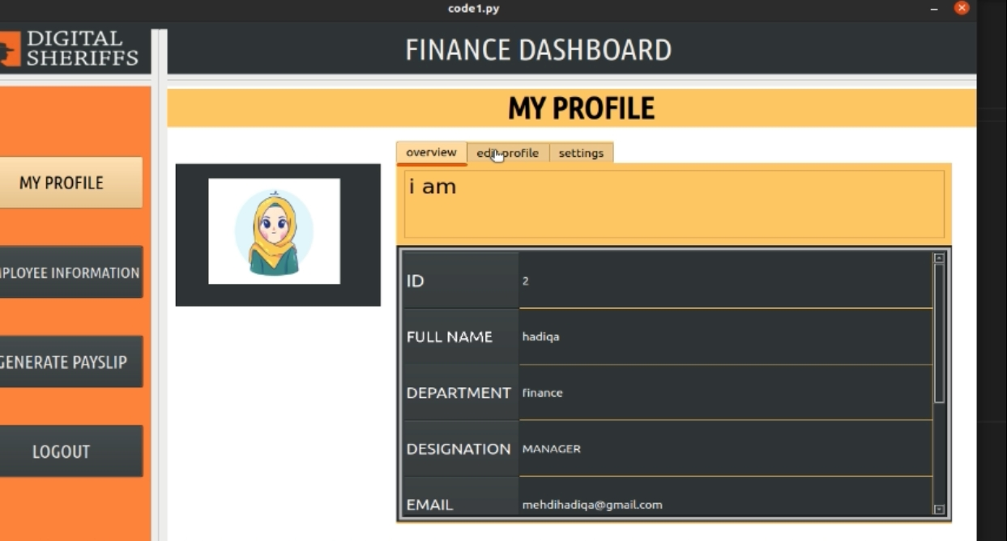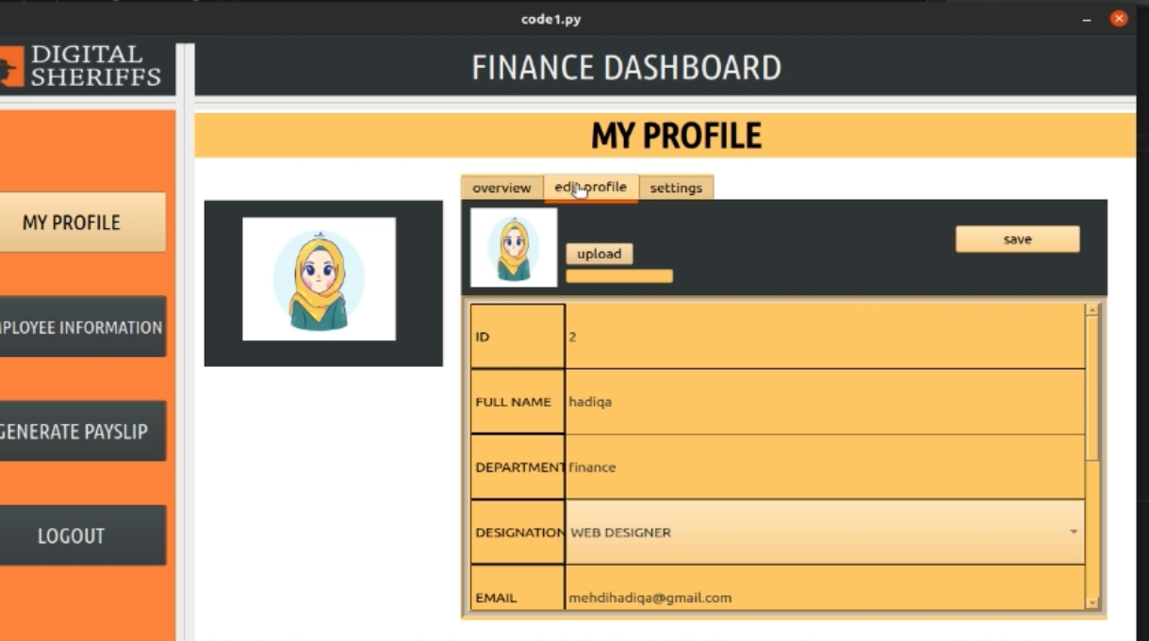: 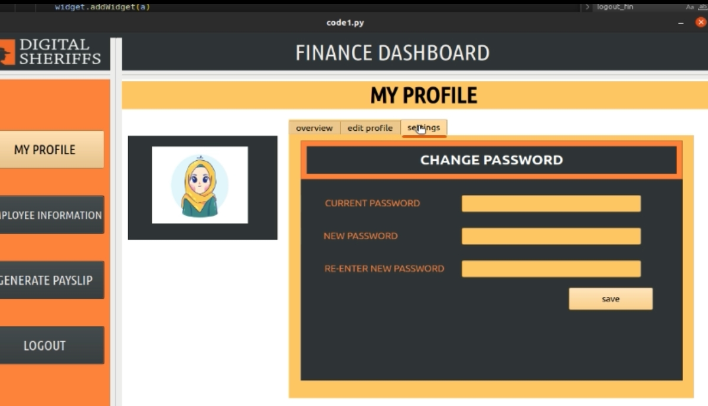

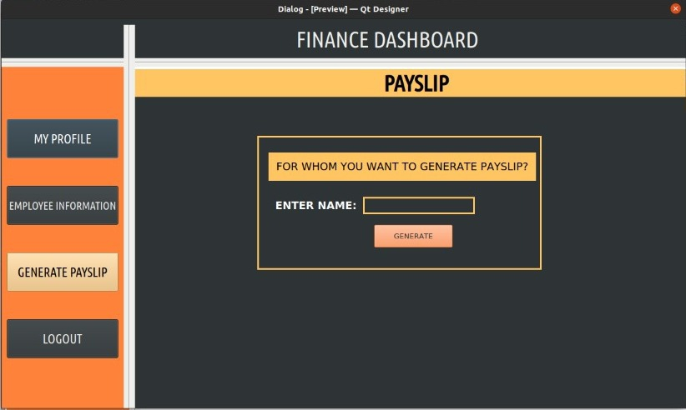

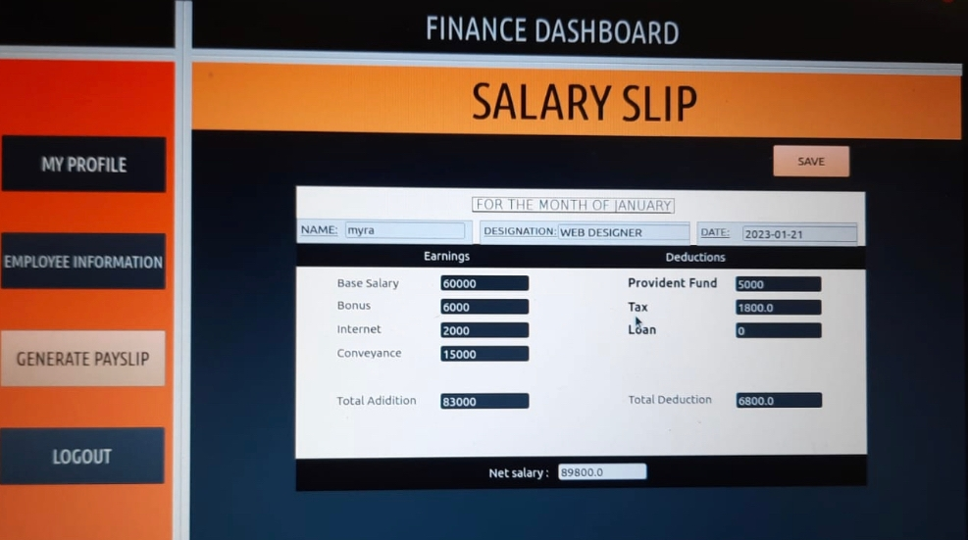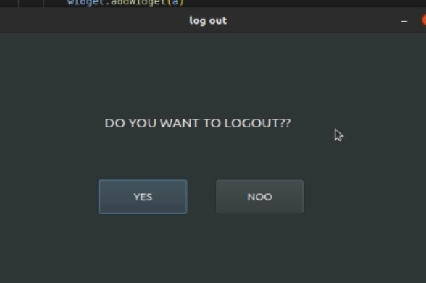

**SUPPORT:**

All the group members support and will be available for all kinds of enhancement, modification and correction of this project when required to this organisation we will provide all types of support and services to this software maintenance and training.

**Conclusions and Suggestions for Future Work:**

The main purpose of this system was to put what we learnt in our software engineering class into practice. We were able to attain our set objectives, and this helped us gain confidence in writing our own code and make our own application. We not just only concentrated on designing or how to store data we also gained experience on how professional work in industry .There is always some room for improvement and the software we created can also be improved especially because e have created this in a limited time with more time it can be improved a lot .This was our original after-thought to programming the software, and we had chosen Python, In addition, the software can be improved by asking for feedback from candidates on your recruitment process and implement their suggestions for improvement and performance monitoring of employee can be improved a lot.

**APPENDICES:**

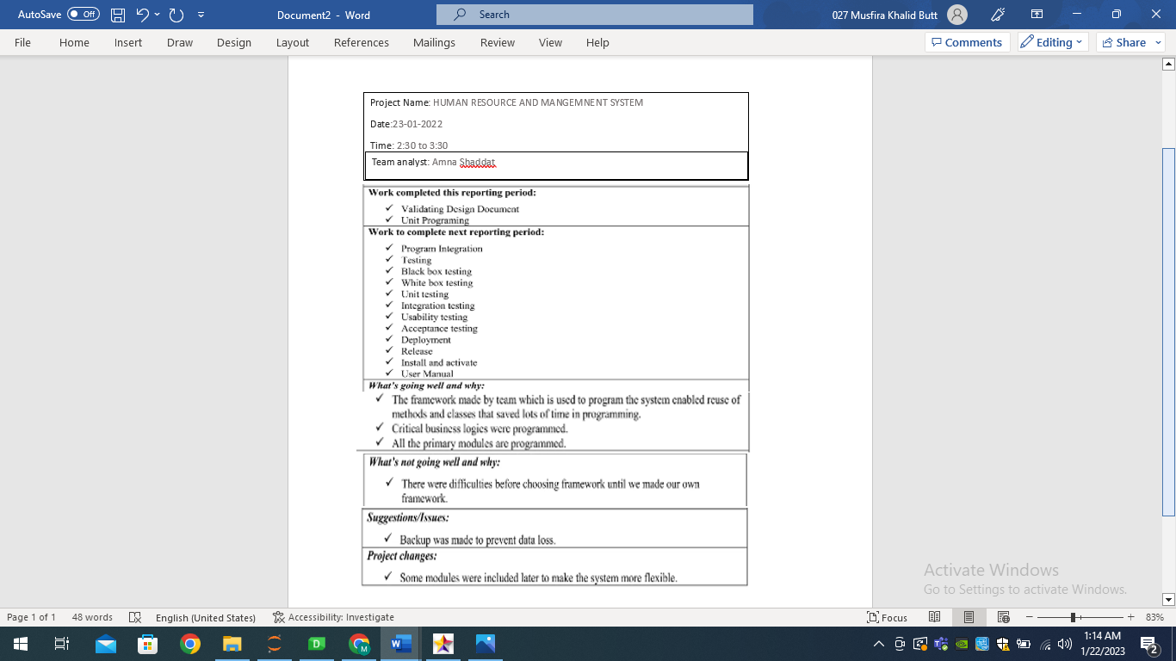

**REFERENCES:**

**1.**[**https://hubstaff.com/features/online_payroll?utm_source=google&utm_medium=cpc&utm_campaign=P_AF_Search&utm_content=SKAG_Payroll_A%2FB_Max-Conv&utm_term=hr%20and%20payroll%20management%20system&gclid=EAIaIQobChMIt9XvxafY_AIVEsbtCh3vqQrpEAAYASABEgI84_D_BwE**](https://hubstaff.com/features/online_payroll?utm_source=google&utm_medium=cpc&utm_campaign=P_AF_Search&utm_content=SKAG_Payroll_A%2FB_Max-Conv&utm_term=hr%20and%20payroll%20management%20system&gclid=EAIaIQobChMIt9XvxafY_AIVEsbtCh3vqQrpEAAYASABEgI84_D_BwE)**.**

**2.**[**https://www.youtube.com/watch?v=pleHwE1swbY**](https://www.youtube.com/watch?v=pleHwE1swbY)

**3.**[**https://www.youtube.com/watch?v=RxGlB9U64fg**](https://www.youtube.com/watch?v=RxGlB9U64fg)

**LIST OF SYMBOLS:**

[UML](https://www.edrawmax.com/uml/) is a standardised modelling language that is used for visualising different types of systems. It was originally developed for software systems. However, it is now adopted for many other systems as well. It employs standard UML notations for visualising, specifying, and documenting different components of a system.

It is a non-programming language whose sole purpose is to document all parts of the system without going deep into the implementation and programming details. Since all stakeholders in a system have different perspectives, UML has several types of diagrams to represent various aspects of the same system. The depth of details, philosophy, and purpose of each UML diagram is different.

Class member notation : (+) for public in diagrams.

Relationships explained with the help of these notations:

